Nepal College of Information Technology
Unit Test
Spring 2010
Program : BE Time : 2 hrs
Semester : Spring (II) FM : 60
Subject : Engineering Math-II PM : 30

- Candidates are requested to give their answer as far as practicable in their own words.
- The figure in the margin indicates the full marks
- Attempt ALL question
1. a) If u= log (x³+y³+z³-3xyz) Show that 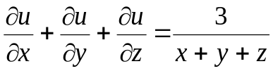 8
b) If f(x,y) be a homogeneous function of two independent variables x and y of degree n, then show that 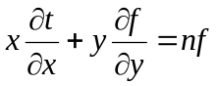 7
2. a) If u = 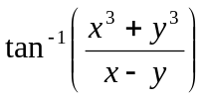 show that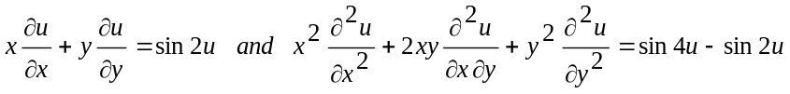 8
b) Find the extreme value of f=48-(x-5)² 3(y-4)² such that x+3y=9 7
3. a) Find the equation of the plane through the points (-1,1,-1), (6,2,1) and normal to the plane 2x+y+z=5 5
b) Find the equation of the plane through the intersection of the planes x+2y-3z=5 and 5x+7y+3z=10 through (-1,2,-3) 5
c) Show that 12x²-2y²-6z²+7yz+6zx-2xy=0 represents the pair of planes and find the angle between them. 5
4. a) Define degree and order of differentiatial equation. Solve (a²+y²)x dx + y(x²-a²) dy=0 7
b) A rectangular box, open at the top, is to have a volume of 32 C.C. Find the dimension of the box requiring least materials for its construction. 8
Nepal College of Information Technology
Unit Test
Spring 2010
Program : BE Time : 2 hrs
Semester : Spring (II) FM : 60
Subject : Engineering Math-II PM : 30

- Candidates are requested to give their answer as far as practicable in their own words.
- The figure in the margin indicates the full marks
- Attempt ALL question
1. a) If u= log (x³+y³+z³-3xyz) Show that 8
b) If f(x,y) be a homogeneous function of two independent variables x and y of degree n, then show that 7
2. a) If u = show that 8
b) Find the extreme value of f=48-(x-5)² 3(y-4)² such that x+3y=9 7
3. a) Find the equation of the plane through the points (-1,1,-1), (6,2,1) and normal to the plane 2x+y+z=5 5
b) Find the equation of the plane through the intersection of the planes x+2y-3z=5 and 5x+7y+3z=10 through (-1,2,-3) 5
c) Show that 12x²-2y²-6z²+7yz+6zx-2xy=0 represents the pair of planes and find the angle between them. 5
4. a) Define degree and order of differentiatial equation. Solve (a²+y²)x dx + y(x²-a²) dy=0 7
b) A rectangular box, open at the top, is to have a volume of 32 C.C. Find the dimension of the box requiring least materials for its construction. 8

